International Airport Professional Community of Practice

[Click here to type your Airport Lab topic]
  - Airport Lab Proposal
Presented by: [airport organization host name]

This Proposal was developed following the IAP CoP Airport Labs Guide produced by The International Airport Professional Community of Practice Administrator – Aviation Strategies International

Table of Contents
Before you get started 1
Lab Purpose and Value Proposition 1
Topic 1
Lab Objective 1
Type of Lab 1
Participant Take-aways 2
Lab Activities 2
Selection Criteria 2
Airport 2
Pricing Standards and Rules 2
Pricing 2
Costs 3
Accommodations and Transportation 3
Budget 3
Fee Collection 3
Force Majeure 4
Timeline for Planning 4
Logistics and Administration 4
Evaluation 4
Marketing Guidelines 5
Logo and Branding Guidelines 5
Airport Lab Flyer 5
Event Promotion 5
Airport Lab Report 5
Production 5
Dissemination Policy 5
Additional comments 6
Focal Point 6

Before you get started
Ensure that you refer to the IAP CoP Airport Labs Guide as you complete this proposal document.
Ensure that you complete every part of this document before submitting it. Incomplete proposals will be returned.
Proposal should be emailed to airportlabs@iapcop.aero.

Also note that the IAP CoP Airport Lab Proposal Template uses forms and fields. The following graphic demonstrates how to use them. 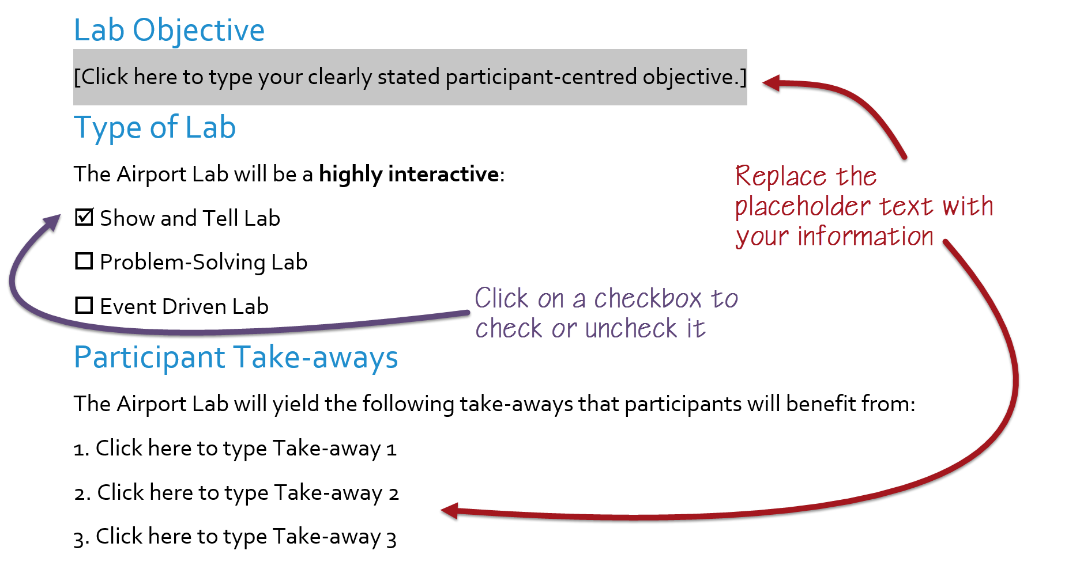
You may delete this highlighted section before submitting your proposal.

Lab Purpose and Value Proposition

Topic
[Click here to type your Airport Lab topic]

Lab Objective
[Click here to type your clearly stated participant-centred objective.]

Type of Lab
The Airport Lab will be a highly interactive:
Show and Tell Lab
Problem-Solving Lab
Event Driven Lab

Participant Take-aways
The Airport Lab will yield the following take-aways that participants will benefit from:
1. Click here to type Take-away 1
2. Click here to type Take-away 2
3. Click here to type Take-away 3

Lab Activities
The Lab will last two days, with a welcome reception the evening before. The types of activities suggested include:
- Click here to type Activity 1
- Activity 2
- Activity 3
- Activity 4
- Activity 5
- Activity 6
- Activity 7
- Activity 8
- Activity 9
- ….

Selection Criteria

Airport
By checking off the following boxes, we confirm that we meet the following criteria:
We have at least one employee enrolled in and/or graduated from the Global ACI-ICAO Airport Management Professional Accreditation Programme (AMPAP).
We have top management buy-in and support for the Airport Lab.
We have a logistics team onsite to plan and manage the Airport Lab.
We have the capacity to host the Airport Lab, with necessary meeting room facilities and accommodations nearby.
With regards to being an IAP CoP Benefactor:
We are currently an IAP CoP Benefactor
We have been an IAP CoP Benefactor in the past
We are not currently an IAP CoP Benefactor

Pricing Standards and Rules

Pricing
The IAP CoP has a set rate for Airport Labs. By checking off the following boxes, we acknowledge the following rules:
There are two registration prices categories: an IAP CoP Regular Member Fee, set at USD $ 1,200, and an IAP Affiliate or Associate Member Fee, set at USD $1,350.
To participate in an Airport Lab, the individual in question must either be a member of the IAP CoP or work for an airport which has at least one AMPAP participant enrolled.

Costs
Hosting an Airport Lab involves costs, some of which can be charged to participants, and others which the host airport organization will be required to bear. By checking off the following boxes, we acknowledge following:
We acknowledge that our host airport organization will contribute of its time, and therefore no time invested by employees shall be charged. In addition, we will deploy 3-4 airport representatives to be with participants at all times.
We acknowledge that the Airport Lab registration fee will cover our host airport’s external hard costs—meals, transportation for offsite visits, etc.—up to an amount not exceeding USD $400 per participant. Any additional hard costs will be absorbed by our organization.
We acknowledge that there is an IAP CoP Administration cost of USD $5000, which includes administration, marketing efforts, processing payments, registration, and other logistics, as well as travel and accommodation for one (1) rapporteur.
We acknowledge that the surplus must be returned to the IAP CoP to support future activities.

Accommodations and Transportation
Airport Lab participants assume the responsibility of their travel and accommodation. However, onsite transportation and meals should be covered by the host airport organization. By checking off the following boxes, we confirm that we assume responsibility for the following:
Provide a list of preferred hotels that are nearby the venue, and when possible, negotiate a group rate.
Provide onsite transportation to and from the venue from preferred hotels, as well as for scheduled activities at set times (off-site tours, etc.).
Provide coffee break refreshments and lunches during the day, as well as during any other event such as a cocktail or group dinner, taking into consideration declared dietary requirements from participants (collected on the registration form).

Budget
The following is our planning budget for the Airport Lab. All amounts are in USD.
Revenues
IAP Regular Member Fee | $ 1,200.00
IAP Affiliate or Associate Member Fee | $ 1,350.00
Participant Fee Average | $ 1,275.00
Registered Participants | N° of participants
Total Estimated Revenues | $ Total estimated revenues
Costs
Host Airport Organization's External Hard Costs (up to at $400/participant) | $ Total external hard costs
IAP CoP Administrator Cost (fixed cost) | $ 5,000.00
Total Estimated Costs | $ Total estimated costs
Surplus to IAP CoP
Total Estimated Surplus | $ Total estimated surplus

Fee Collection
We acknowledge that the IAP CoP Administrator will collect the fees for the Airport Lab, and will remit the agreed upon amount to cover hard external costs per actual registered participant who attended to our host airport organization after the event.
We acknowledge that we may enroll some of our employees to the Airport Lab as participants, and will do so at the same cost of as other participants.

Force Majeure
We acknowledge that there are, at times, last minute issues such as a participant’s inability to obtain a visa, cancelled flights, and elements of force majeure which prevent a participant from attending, and it is the policy of the IAP CoP in this case to reimburse the participant. Therefore, the agreed upon amount to cover hard external costs per actual registered participant will not be remitted for participants who had to cancel due to force majeure.

Timeline for Planning
The following is our timeline for planning our IAP CoP Airport Lab:
Activity | Timeline
Request to host an Airport Lab | Enter date, at least event -140 days
Agreement on topic, dates, schedule budget and price | Enter date, at least event -120 days
Development of promotional materials | Enter date, at least event -100 days
Announcement and call for registration | Enter date, at least event -90 days
Registration of participants | Enter date, at least event -7 days
Continuous marketing efforts | Enter date, at least event -7 days

Logistics and Administration
We acknowledge that in addition to leading the marketing initiatives, the IAP CoP Administrator will take care of:
- Providing a registration form
- Facilitating payment
- Handling all registration inquiries
- Providing a visa letter to participants requiring one
- Producing a newsletter for participants with all the logistical information that they will require as make their way to the event
We acknowledge that as the host airport organization, we will be fully responsible for any and all logistical requirements onsite.

Evaluation
We acknowledge that the IAP CoP Administrator will provide evaluation forms to all participants, and will compile the results, and will share these with us.

Marketing Guidelines

Logo and Branding Guidelines
We acknowledge that the IAP CoP Airport Lab Series are an IAP CoP Event which are sponsored by SITA. The banner which is featured on the cover of this guide shall be present on all promotional and event material in proportionally the same size as the host organization’s logo. All mention of the Lab must ensure to reflect this co-branding.

Airport Lab Flyer
The Airport Lab PDF flyer (letter or A4, two sided) which contains all the pertinent information regarding the Airport Lab (dates, location, hotel information, scheduled, etc.) will be:
Develop by us, based examples of previous flyers will be provided for reference.
By the IAP CoP Administrator, and we will provide high resolution images representing our airport organization, as well as a vector version of our logo

Event Promotion
While the IAP CoP Administrator will ensure marketing to the entire IAP CoP Community which includes all participants in AMPAP, as the host airport organization we propose to undertake the following promotional activities:
- Click here to type Promotional activity 1
- Promotional activity 2
- Promotional activity 3
- Promotional activity 4
- Promotional activity 5
- Promotional activity 6
- ….

Airport Lab Report

Production
Within two (2) weeks of the Airport Lab, the Administrator Representative onsite will produce a report summarizing the activities, and highlighting discoveries. The sections of the report will include:
- Executive Summary
- Background
- List of participants
- List of activities with summaries and highlights
- Description and findings from the workshop
- Debrief and Take-Aways
- Appendices including promotional materials, presentation material and any other relevant information
We agree to share all presentation material and photographs with the Administrator within five (5) business days after the event so that they may produce the report.

Dissemination Policy
There will be two versions of the Airport Lab report: a full version which will be available to all attendees and a summary version which will be available to the IAP CoP at large, and which will also eventually be published regularly as part of a “Compendium of Best Practices”.

Additional comments
Enter any additional comments not covered by points above.

Focal Point
The contact information for our Airport Lab focal point is as follows:
Full name: Enter first and last name
Title: Enter the full title
Email: Enter the email address
Phone: Enter the phone number

In some cases, participants will request a letter from the host organization due to the specifics of their Visa process, in which case, the administrator will make the request to the host organization.
The administrator has a template which will require information from the host organization, such as contact information and location of events. Nevertheless, the administrator will create the document.

